

CONAGRA PROJECT PROPOSAL

Group - 14



Team MEMBERS

Sahith Varma Mudunoori - sxm230112

Sakshi Gona - sxg230084

Kaoshik Reddy Kolathoor - kxk230001

Prathamesh P Nagraj - pxn230011

Vandan T Raval - vxr230011

Dhruv Rajesh Shah – drs230002

Sowmya Kothari - sxk230001

|  |  |  |
| --- | --- | --- |
| Sr. No. | Content | Page Number |
| 1 | **Executive Summary** | **2** |
| 2 | **Introduction** | **2** |
| 3 | **Market Overview** | **3** |
| 4 | **Market Drivers and Restraints** | **3** |
| 5 | **Market Trends** | **3** |
| 6 | **Competitive Landscape** | **4** |
| 7 | **Market Segmentation** | **4** |
| 8 | **Source** | **4** |
| 9 | **Distribution Channel** | **5** |
| 10 | **Regional Analysis** | **5** |
| 11 | **Consumer Insights** | **5** |
| 12 | **Regulatory** **Landscape** | **5** |
| 13 | **Future Outlook** | **6** |
| 14 | **Recommendations** | **6** |
| 15 | **Data Visualization** | **7** |
| 16 | **Proposal** | **10** |
| 17 | **Conclusion** | **13** |
| 18 | **References** | **13** |

**Table of Contents**

**Market Research Report: Meat Substitutes**

**Executive Summary**

* **Overview**

The global market for meat substitutes is experiencing rapid growth, driven by increasing consumer awareness of health benefits, environmental concerns, and ethical considerations. With a market size valued at USD 18.78 billion in 2023 and expected to grow at a compound annual growth rate (CAGR) of 42.4% from 2024 to 2030, Conagra Brands has a significant opportunity to capitalize on this trend.

* **Key Findings and Insights**
  + Consumers are actively seeking alternatives to traditional meat products due to concerns about health, sustainability, and animal welfare.
  + Plant-based protein sources, such as soy, pea, and wheat, are gaining popularity as substitutes for meat.
  + Product innovation, strategic partnerships, and effective marketing are key drivers of success in the meat substitutes market.
* **Summary of Market Trends, Challenges, and Opportunities**
  + Current trends include the introduction of new product varieties, celebrity endorsements, and the expansion of distribution channels.
  + Challenges include regulatory compliance, consumer scepticism, and competition from traditional meat producers.
  + Opportunities exist for Conagra Brands to develop innovative products, establish strategic partnerships, and target niche consumer segments.

**Introduction**

* **Background Information**

The meat substitutes industry consists of products made from vegetarian or vegan ingredients that mimic the taste, texture, and appearance of meat. These products are consumed as alternatives to traditional meat products for various reasons, including health, environmental, and ethical concerns.

* **Purpose and Scope**

This report aims to provide Conagra Brands with insights into the meat substitutes market, including market size, growth projections, consumer preferences, competitive landscape, and regulatory considerations. The report will inform strategic decision-making and help identify opportunities for market entry and expansion.

* **Methodology**

Data for this report was collected from primary and secondary sources, including market research reports, industry publications, company websites, and government sources. Analysis was conducted to synthesize key findings and insights into a comprehensive market research report.

**Market Overview**

* **Definition and Classification**

Meat substitutes encompass a wide range of products made from vegetarian or vegan ingredients, including soy, pea, wheat, and mushrooms. These products are designed to replicate the taste, texture, and appearance of meat and are consumed as alternatives by vegetarians, vegans, and flexitarians.

* **Market Size and Growth Projections**

The global meat substitutes market was valued at USD 18.78 billion in 2023 and is projected to grow at a CAGR of 42.4% from 2024 to 2030. Key factors driving market growth include increasing consumer awareness of health benefits, environmental concerns, and ethical considerations.

* **Key Market Segments**
  + Product Type: Meat substitutes are available in various forms, including burgers, sausages, nuggets, and deli slices.
  + Source: Plant-based ingredients such as soy, pea, wheat, and mushrooms are the primary sources of meat substitutes.
  + Distribution Channel: Meat substitutes are sold through retail channels such as supermarkets, convenience stores, and online platforms.

**Market Drivers and Restraints**

* **Drivers**
  + Health Consciousness: Consumers are increasingly seeking healthier dietary options, including plant-based protein sources.
  + Environmental Concerns: The environmental impact of meat production, including greenhouse gas emissions and deforestation, is driving demand for sustainable alternatives.
  + Ethical Considerations: Animal welfare concerns and ethical objections to factory farming motivate consumers to choose plant-based alternatives.
* **Restraints**
  + Regulatory Compliance: Strict regulations govern the production, labelling, and marketing of meat substitutes, posing challenges for manufacturers.
  + Consumer Scepticism: Some consumers are sceptical about the taste, texture, and nutritional value of meat substitutes, limiting market acceptance.
  + Competition from Traditional Meat Producers: Established meat producers may perceive meat substitutes as a threat to their market share and may resist market innovation.

**Market Trends**

* **Product Innovation**
  + Companies are innovating to develop new meat substitute products with improved taste, texture, and nutritional profiles.
  + Plant-based burgers, sausages, and nuggets are increasingly indistinguishable from their meat counterparts, appealing to a broader consumer base.
* **Strategic Partnerships**
  + Collaboration between food manufacturers, retailers, and food service providers is driving product innovation and expanding distribution channels.
  + Partnerships with celebrity chefs and influencers are enhancing brand visibility and credibility in the market.
* **Marketing Strategies**
  + Effective marketing campaigns emphasize the health, environmental, and ethical benefits of meat substitutes.
  + Celebrity endorsements, social media influencers, and product placements drive consumer awareness and demand.

**Competitive Landscape**

* **Major Companies**
  + Beyond Meat: A leading player in the meat substitutes market, known for its plant-based burgers, sausages, and chicken alternatives.
  + Impossible Foods: Another prominent player, known for its realistic meat-like products, including the Impossible Burger.
  + Quorn: A well-established brand offering a diverse range of meat substitutes made from mycoprotein, including burgers, nuggets, and deli slices.
* **Competitive Analysis**
  + Companies compete on product quality, taste, and brand reputation to gain market share.
  + Innovation in product development, strategic partnerships, and effective marketing are key differentiators in the competitive landscape.

**Market Segmentation**

* **Product Type**
  + Burgers: Plant-based burgers are the most popular meat substitute product, available in various flavours and textures.
  + Sausages: Plant-based sausages are gaining popularity as breakfast and grilling options, offering alternatives to traditional meat sausages.
  + Nuggets: Plant-based nuggets are a favourite among children and adults alike, providing a convenient and tasty snack option.

**Source**

* + Soy: Soy-based meat substitutes are widely available and offer a complete protein source with a meat-like texture.
  + Pea: Pea protein is increasingly used in meat substitutes for its nutritional value and sustainability.
  + Wheat: Seitan, a wheat-based meat substitute, is popular for its chewy texture and versatility in cooking.

**Distribution Channel**

* + Retail: Supermarkets, convenience stores, and online platforms are the primary retail channels for meat substitutes.
  + Foodservice: Restaurants, cafes, and fast-food chains are incorporating meat substitutes into their menus to cater to consumer demand.

**Regional Analysis**

* **Europe**
  + Europe is the largest market for meat substitutes, driven by a strong culture of vegetarianism, environmental awareness, and health consciousness.
  + Major markets include the United Kingdom, Germany, and the Netherlands, where plant-based diets are increasingly popular.
* **North America**
  + North America is experiencing rapid growth in the meat substitutes market, fueled by increasing consumer demand for plant-based protein sources and concerns about health and sustainability.
  + The United States and Canada are the largest markets, with significant investments in product innovation and marketing.
* **Asia Pacific**
  + Asia Pacific is an emerging market for meat substitutes, driven by changing dietary habits, urbanization, and rising disposable incomes.
  + Countries such as China, Japan, and India are experiencing growing demand for plant-based protein sources, particularly among younger consumers.

**Consumer Insights**

* **Consumer Attitudes**
  + Consumers are increasingly interested in plant-based diets for health, environmental, and ethical reasons.
  + Taste, texture, and nutritional value are key factors influencing consumer acceptance and adoption of meat substitutes.
* **Purchase Behaviour**
  + Millennials and Generation Z consumers are driving demand for meat substitutes, seeking healthier, more sustainable food options.
  + Flexitarians, vegetarians, and vegans are the primary target demographics for meat substitute products, but there is also potential to attract meat-eaters looking to reduce their meat consumption.

**Regulatory** **Landscape**

* **Labelling Standards**
  + Regulatory authorities enforce precise labelling standards to ensure transparency and accurate information for consumers.
  + Labelling requirements include disclosure of specific food ingredients, their concentrations, and any potential allergens to ensure consumer safety and compliance with regulations.
* **Compliance Requirements**
  + Food manufacturers must adhere to strict regulations governing the production, labelling, and marketing of meat substitutes to ensure product safety and consumer trust.
  + Compliance with regulatory requirements is essential for market entry and expansion, requiring ongoing monitoring and adaptation to changing regulations.

**Future Outlook**

* **Market Forecast**
  + The meat substitutes market is expected to continue its rapid growth trajectory, driven by increasing consumer demand for plant-based protein sources and ongoing innovation in product development and marketing.
  + Emerging opportunities include expansion into new geographic markets, development of innovative product offerings, and collaboration with strategic partners to enhance market penetration and brand visibility.
* **Challenges and Opportunities**
  + Challenges such as regulatory compliance, consumer skepticism, and competition from traditional meat producers will require proactive strategies to address.
  + Opportunities exist for Conagra Brands to leverage its expertise in food manufacturing, distribution, and marketing to develop innovative meat substitute products, establish strategic partnerships, and capture market share in this rapidly growing industry.

**Recommendations**

* **Product Development**
  + Invest in research and development to create innovative meat substitute products that meet consumer demand for taste, texture, and nutritional value.
  + Expand product lines to include a variety of meat substitute options, catering to different dietary preferences and culinary preferences.
* **Marketing Strategies**
  + Develop targeted marketing campaigns that emphasize the health, environmental, and ethical benefits of meat substitutes to resonate with consumer values and preferences.
  + Collaborate with influencers, chefs, and celebrities to enhance brand visibility and credibility in the market.
* **Strategic Partnerships**
  + Form strategic partnerships with retailers, food service providers, and other industry stakeholders to expand distribution channels and reach new consumer segments.
  + Collaborate with suppliers and manufacturers to ensure a consistent supply chain and high-quality ingredients for meat substitute products.

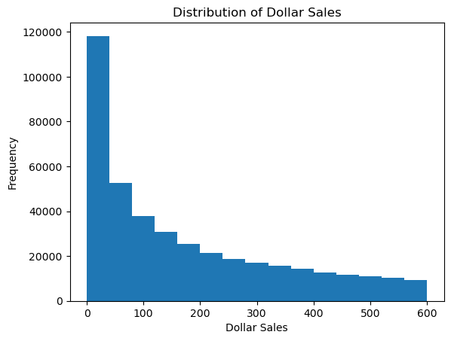**Data Visualization**

* The above plots are attempted to plot the distribution of Dollar Sales
* On the right is the logarithmic distribution of Dollar Sales while on the left is the distribution of Dollar Sales as is.
* The same message is conveyed in the box plots below.

* A graph with different colored bars

  Description automatically generated with medium confidenceThe above bar plot provides a comparison between the top 5 products from the Gardein brand and the top 5 products from other brands based on their dollar sales.
* It visualizes the relative performance of Gardein's top products against those of other brands.
* This Comparison gives an understanding of how Gardein's key products fare against those of its competitors in terms of revenue generation.
* 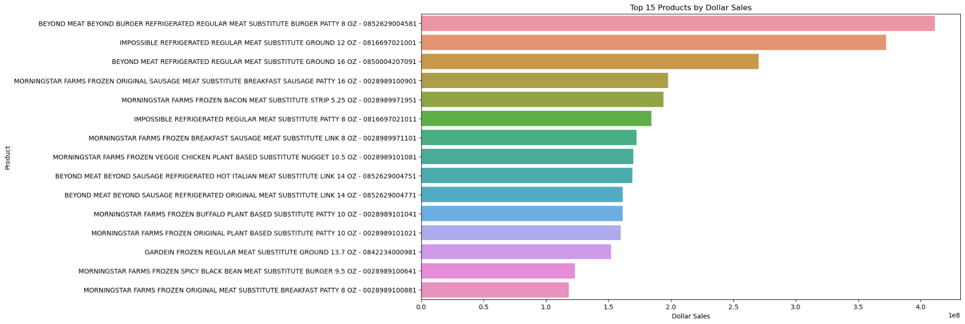Additionally, the comparison reveals Gardein's top 5 products have lower dollar sales compared to the top 5 products of other brands.
* This Bar plot above visualizes the top 15 products based on their dollar sales, with each bar representing the dollar sales value of a specific product.
* It provides a quick overview of the highest-performing products in terms of sales, allowing for easy comparison and the identification of the top performers.
* Gardein's top performer being Gardein frozen regular meat substitute ground 13.7 OZ, ranking at the 13th position.
* The Bar plot above illustrates the sales volume of the top 10 products, with each bar representing the volume sales attributed to a specific product.
* 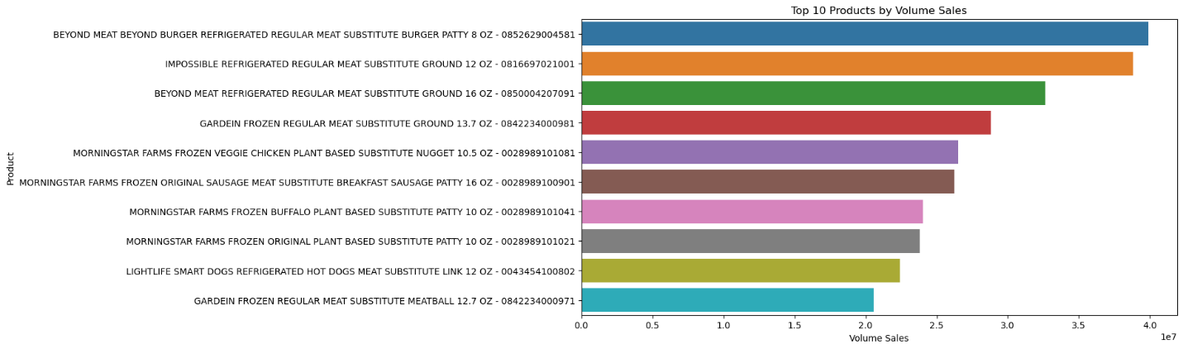Notably, "Gardein frozen regular meat substitute ground 13.7 OZ" emerges as the fourth-highest seller in terms of volume.
* This insight underscores its significant contribution to overall sales volume within the product lineup.
* Visualization aids in swiftly identifying the highest-selling products by volume, enabling informed decision-making regarding sales strategies and product optimization efforts.
* The plot facilitates comparative analysis between different products, into their relative performance in terms of sales volume

Correlation Matrix and Heatmap among a few variables:

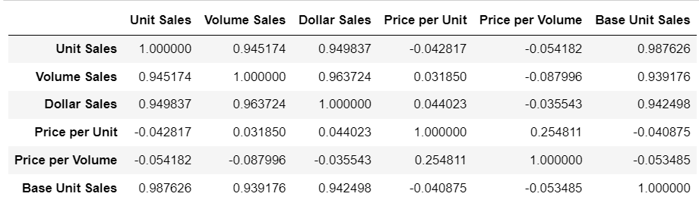

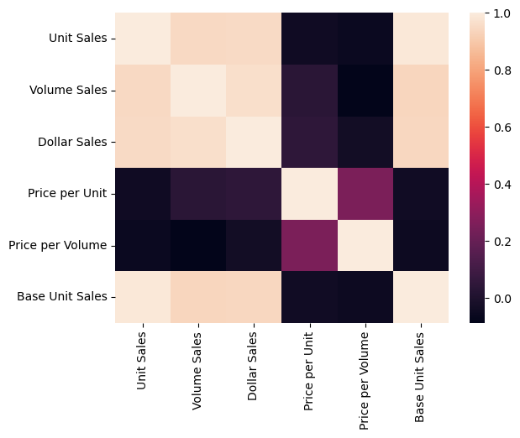

**Proposal:** To accelerate growth within the Meat Substitutes category, it is crucial to analyze various aspects that impact sales and market competitiveness. This report outlines the questions we aim to address and proposes potential approaches to finding solutions.

**Possible questions and approach to the solution:**

Question 1: What promotional tactics can be employed to increase Gardein Dollar Sales? How can we leverage “Price Reductions”, “Special Packs”, etc. to increase Dollar Sales?

We plan to follow this step-by-step approach:

Approach:

* Data Exploration:
  + Begin by thoroughly exploring the dataset to understand the distribution of variables, identify any missing values, and gain insights into the range and variability of the data.
  + Focus on understanding the distribution of Dollar Sales and the other relevant variables such as Unit Sales, Price per Unit, Volume Sales, and promotional tactics (e.g., Price Reductions, Special Packs, etc.).
* Descriptive Analysis:
  + Conduct descriptive analysis to identify trends and patterns in Dollar Sales and other variables over time (if time series data is available), across different geographies, and within various product categories and sub-categories.
  + Analyze the relationship between Dollar Sales and promotional tactics such as Price Reductions, Special Packs, Feature Displays, etc. to understand their impact on sales.
* Correlation Analysis:
  + Calculate correlation coefficients between Dollar Sales and other variables to identify which factors are most strongly associated with sales.
  + Specifically, analyze the correlation between Dollar Sales and promotional tactics like Price Reductions, Special Packs, etc., to determine their impact on sales performance.
* Promotional Tactics Effectiveness:
  + Evaluate the effectiveness of different promotional tactics (e.g., Price Reductions, Special Packs) on Dollar Sales by comparing sales performance during promotional periods versus non-promotional periods.
  + Calculate metrics such as sales lift, ROI (Return on Investment), and incremental sales to assess the impact of each promotional tactic on Dollar Sales.
* Segmentation Analysis:
  + Segment the data based on various factors such as geography, product type, package size, etc., and analyze the effectiveness of different promotional tactics within each segment.
  + Identify segments that respond positively to specific promotional tactics and tailor marketing strategies accordingly to maximize Dollar Sales.
* Predictive Modelling:
  + Build predictive models using techniques such as regression analysis or machine learning algorithms to forecast Dollar Sales based on various factors including promotional tactics.
  + Evaluate the predictive power of different variables including Price Reductions, Special Packs, etc., and identify the most influential factors for driving Dollar Sales.
* Optimization Strategies:
  + Use insights gained from the analysis to develop optimization strategies for increasing Dollar Sales through promotional tactics.
  + Determine the optimal pricing strategies, promotional offers, and product bundling options to maximize revenue while considering factors such as consumer preferences, competitive landscape, and market dynamics.

Question 2: What product attributes (form, flavor, size, etc.) have an impact on Dollar Sales?

To determine which product attributes, have an impact on Dollar Sales, we plan to follow this step-by-step approach:

Approach:

* Data Exploration:
  + Begin by thoroughly exploring the dataset to understand the available product attributes and their distributions.
  + Identify the variables related to product attributes such as form (e.g., frozen, canned), flavor, size, package type, etc.
* Descriptive Analysis:
  + Conduct descriptive analysis to identify trends and patterns in Dollar Sales based on different product attributes.
  + Compare Dollar Sales across various levels of each product attribute (e.g., different flavors, sizes, forms) to understand their impact.
* Correlation Analysis:
  + Calculate correlation coefficients between Dollar Sales and each product attribute to identify the strength and direction of their relationship.
  + Focus on attributes with higher correlation coefficients as they are more likely to have a significant impact on Dollar Sales.
* Segmentation Analysis:
  + Segment the dataset based on different product attributes such as flavor, form, size, etc.
  + Analyze Dollar Sales within each segment to identify which product attributes are associated with higher sales performance.
* Visualizations:
  + Create visualizations such as bar charts, histograms, or box plots to visually explore the relationship between Dollar Sales and different product attributes.
  + Use these visualizations to identify any patterns or trends that emerge across different product attribute categories.
* Statistical Testing:
  + Perform statistical tests such as ANOVA or t-tests to determine if there are statistically significant differences in Dollar Sales across different levels of each product attribute.
  + This step helps validate whether certain product attributes have a significant impact on Dollar Sales.
* Feature Importance:
  + Utilize machine learning algorithms or feature importance techniques to determine the importance of different product attributes in predicting Dollar Sales.
  + Identify the top-ranking product attributes based on their contribution to predicting sales.
* Validation and Interpretation:
  + Validate the findings by interpreting the results in the context of consumer preferences, market trends, and industry insights.
  + Consider conducting surveys or focus groups to gather additional qualitative feedback on the importance of specific product attributes to consumers.
* Actionable Insights:
  + Use the insights gained from the analysis to inform product development, marketing strategies, and pricing decisions.
  + Prioritize product attributes that have the greatest impact on Dollar Sales when developing new products or optimizing existing ones.

**Conclusion**

* The meat substitutes market presents significant opportunities for Conagra Brands to capitalize on growing consumer demand for plant-based protein sources. By leveraging its expertise in food manufacturing, distribution, and marketing, Conagra Brands can develop innovative products, establish strategic partnerships, and capture market share in this rapidly growing industry.
* By systematically analyzing promotional tactics and product attributes impacting Gardein Dollar Sales, Conagra can develop targeted strategies to improve sales growth. Insights gained from these analyses will inform decision-making for promotional activities, product development, and marketing strategies, ultimately driving revenue optimization and market competitiveness.

**References**

1. Global Meat Substitutes Market Report 2023-2030, Market Research Firm.

2. "Understanding Consumer Trends in the Meat Substitutes Market," Industry Publication.

3. Regulatory Guidelines for Meat Substitute Products, Food Safety Authority.

4. "Plant-Based Protein: Market Trends and Opportunities," Market Research Report.

5. "The Rise of Meat Substitutes: Implications for Food Manufacturers," Industry Insights.